Internship – VR/Unity

**Learning Geology with Immersive Simulations**

VENISE team - LISN/CNRS

Supervisor : Jeanne Vézien - [vezien@lisn.fr](mailto:vezien@lisn.fr)

From an early age, our understanding of physical reality is shaped by direct, interactive experimentation that links perception and cognition. Building on this idea, our research explores how immersive and interactive digital simulations can enhance learning. We propose that Virtual Reality (VR) offers unique advantages over traditional teaching methods.

To investigate this hypothesis, we focus on the field of Geology, where key concepts—such as rock layering, sedimentation, and erosion—are closely tied to real-world terrain observation. Because natural formations rarely match ideal theoretical models, field observations must be guided and interpreted according to students’ knowledge and available analytical tools (e.g., maps). Based on classroom observations, a VR learning prototype for geology, creating virtual field trip experiences, has already been developed in our lab.

The objective of this internship is to evaluate the quality of interaction within this functional VR prototype using two main criteria: **learning performance** and **user satisfaction**. These will be assessed through qualitative and quantitative methods, including satisfaction and engagement questionnaires, pre-/post-knowledge tests, and behavioral analysis during virtual exploration. The intern will also take part in **co-design sessions** with geology teachers and students from the GeoSciences Institute of Paris-Saclay to identify possible improvements to the tool. This project provides an opportunity to gain experience in **human–computer interaction, immersive learning, and experimental evaluation** within a multidisciplinary research environment.

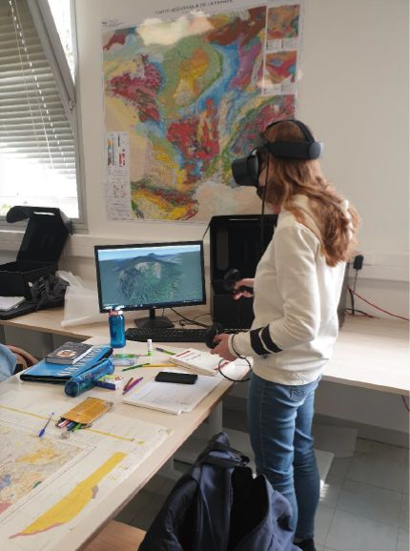

REQUIRED SKILLS:

* Previous experience in VR/AR development frameworks and interfaces (e.g. openXR)
* Knowledge in design and evaluation of HCI
* Basic skills in Unity / C#